AM 310 – Instrumentation and Theory of Experiments

Flow Measurement and Calibration

CONCEPTS: Bernoulli’s equation, flowmeter calibration (rotameter, orifice meter, turbine flowmeter), use of manometers, 4-20 mA current loop transmitter.

- Introduction

The quantitative measurement of liquid flow is important in many laboratory investigations and perhaps even more important in industry and commerce where applications range from measurement of oil production to that of water for household use. These applications involve the measurement of total volume of liquid produced or consumed; related to this is the measurement of flow rate, i.e. the amount of liquid flowing in a pipe or conduit in a particular amount of time – one way to determine the total volume is to measure the time-dependent flow rate and calculate the total volume flow from this data.

In this lab you will learn about and calibrate three different flow meters. The apparatus you will use should be familiar to you – it is the same one used in the Introduction to Fluids Dynamics class (EK 304) for the lab in which you studied pipe friction. The three meters are called a rotameter, an orifice meter and a turbine meter, the theory of operation of each of these meters is described below.

- Theory

  - Rotameter

The rotameter has a vertical tapered tube with a metal “float” free to move up or down in it; as the float rises, the clearance between the float and the walls of the tube increases. When flow is increased through the meter, the float rises to the point where the pressure drop across it due to the flow around it is balanced by its weight. The rotameter reading is taken at the widest edge of the tapered part of the float (see Figure 1).
Float
Read Scale at this surface
Tapered Tube
Scale
Flow
Figure 1: Rotameter

  - Turbine Flowmeter and 4-20 mA Current Loop Signal Transmission

Another method of measuring flow is to measure the fluid velocity with a turbine. The fluid turns the blades of the turbine, as shown in Figure 2. A sensor sends out a voltage pulse for every revolution of the turbine. This type of flowmeter is very accurate at flow rates high enough that the turbine friction is negligible; however, its accuracy also depends on the shape of the velocity profile, and therefore is more susceptible to fouling than an orifice meter (orifice meters are discussed in the next section).
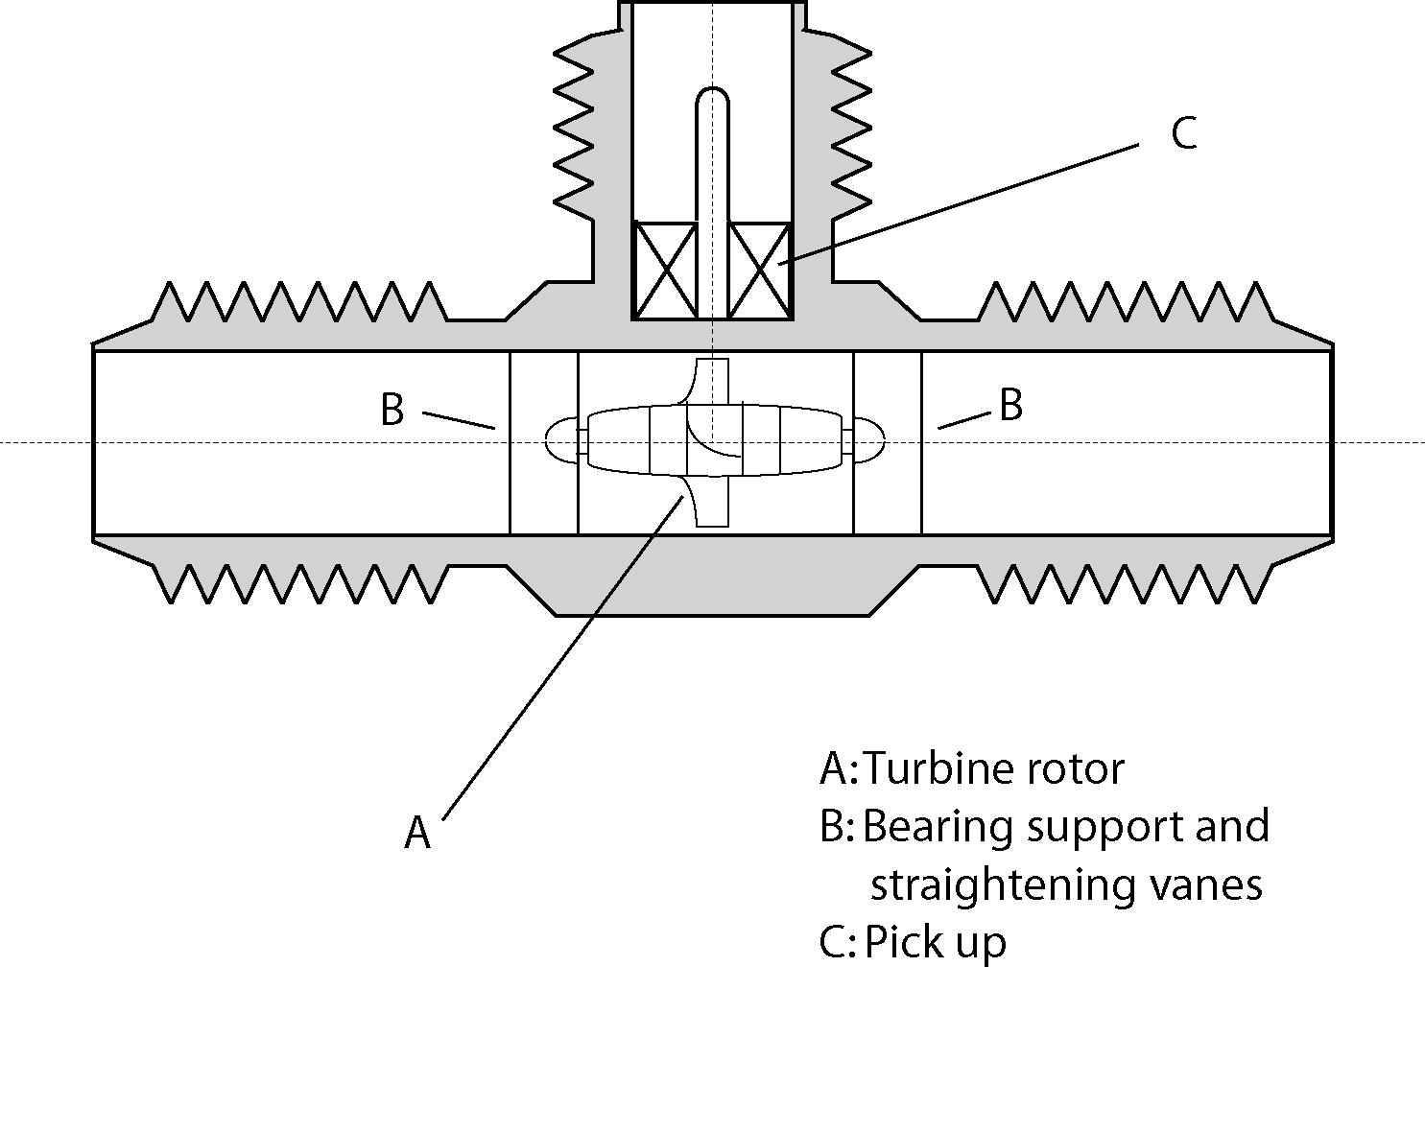
Figure 2: Turbine flowmeter

The pulse output of the turbine meter can be read directly on an oscilloscope or pulse counter, or can be read directly as a frequency on a frequency meter. In addition, the voltage pulse produced by the turbine meter can be converted to a steady DC voltage reading or a steady DC amperage (current) reading by a signal conditioner. Steady DC voltages are useful for computer interfacing through a standard A/D (or DAQ) board, as will be done in the Temperature Calibration and Measurement experiment. Voltages produced by transducers are subject to electromagnetic noise interference and degradation if they must be transmitted long distances. Therefore, for long distance transmission of data from a transducer to a recorder or computer, the signal is often carried as a DC current instead of a DC voltage. Low level DC currents are less subject to electromagnetic noise interference and degradation than low level voltages. The conversion from DC voltage to DC current is often done through the use of a 4-20 mA current loop. The transducer is connected to a signal conditioner which converts the transducer output signal into a DC current varying between 4 mA for a zero transducer output signal to 20 mA for a maximum transducer output signal. The current can either be read directly at the receiving location, or converted into a voltage by inserting a resistor of known resistance in the current loop and measuring the voltage across the resistor.

In this lab, you will be measuring the output pulses of the turbine meter directly, as well as sending the signal out over a 4-20 mA current loop and measuring the current in the loop and voltage across a 200 ohm resistor. The signal conditioner used with the turbine meter in this experiment plays a second important role in addition to pulse to DC conversion – it provides a 12V DC excitation voltage required by the turbine meter to operate correctly.

  - Orifice Meter

An orifice meter (Figure 3) uses an orifice to generate a pressure drop in a fluid flow. An orifice is simply a sharp edged hole in a plate placed perpendicular to the direction of flow. The orifice causes a sharp contraction in the flow area. For incompressible fluids, the volume flow rate through the orifice meter is related to the pressure drop as:

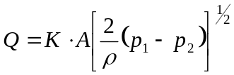 (1)

where A is the cross-sectional area of the hole, K is a constant of proportionality, ρ is the density of the fluid (in this case, water), p₁ is the pressure upstream of the orifice and p₂ is the pressure downstream of the orifice. For a given orifice area and fluid density, Q is proportional to (p₂–p₁)^{1/2}. In this experiment, the pressure drop (i.e. the pressure difference between the pressures at positions 1 and 2 in Figure 2) will be measured by a vertical manometer (for high flow rates) or an inclined manometer (for low flow rates).

Flow
1
2
Orifice
Pipe walls
Figure 3: Orifice Meter

- Experiment

The experiments will be conducted with the apparatus shown schematically in Figures 4, 5 and 6. The flow rate is measured with the rotameters on the supply panel. The large rotameter has a scale which reads directly in gallons per minute. The two smaller rotameters read as a percentage of full scale. The scaling factor for these rotameters can be found on the left sides of their cases. You will be calibrating the medium rotameter.

Additional equipment required:

• Digital multimeters (3)

• Frequency meter/pulse counter (counter/timer)

• Oscilloscope

• Pulse to mA signal conditioner

• Thermometer

• Level

• Bucket

• Stopwatch

• Weigh Scale

The vertical manometer is a pair of vertical transparent glass tubes with a scale to read the water level in the tubes, see Figure 6. The flexible tubes from the pressure taps are connected through manifolds to the bottom of the manometer tubes. The connection between the tops of the manometer tubes can be either vented to the atmosphere or sealed to provide an enclosed air space between the tubes by means of a plastic ball valve. If an enclosed air space is employed, the pair of tubes become an inverted U-tube manometer and can be used to measure pressure differences even when the individual pressures exceed the range of the manometer when the tubes are vented to the atmosphere. The pressure difference is inferred by measuring the difference in height of the two water columns and using Bernoulli’s law. As part for you pre-lab preparation, write down the expression that relates the height difference to the pressure difference. When using the manometers, it is very important to remove all air bubbles in the connecting tubing, manifolds, and manometers. The inclined manometer works like the vertical manometer, but with greater sensitivity due to its angle of inclination. It should be used when measuring small pressure differences. Be sure to take into account that the vertical height difference between the two water columns is related to, but not the same as, the distance measured along the inclined tubes.

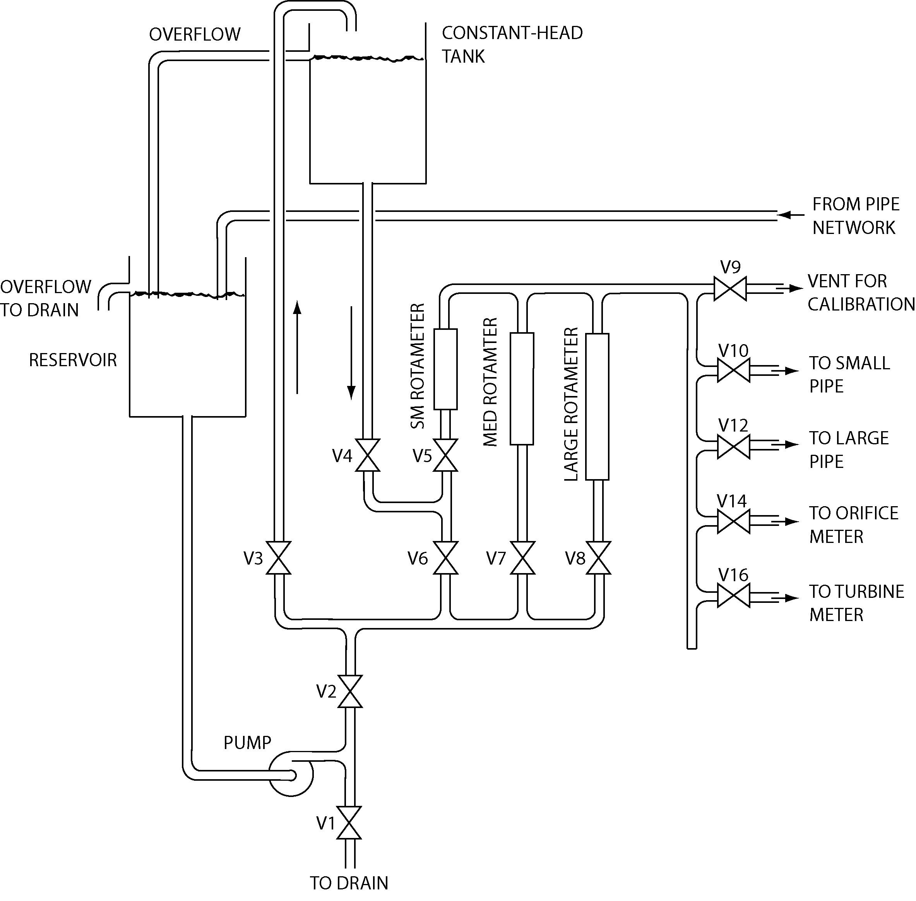
Figure 4: Supply for pipe network. In this lab, you will not use the small rotameter, constant-head tank and associated piping.
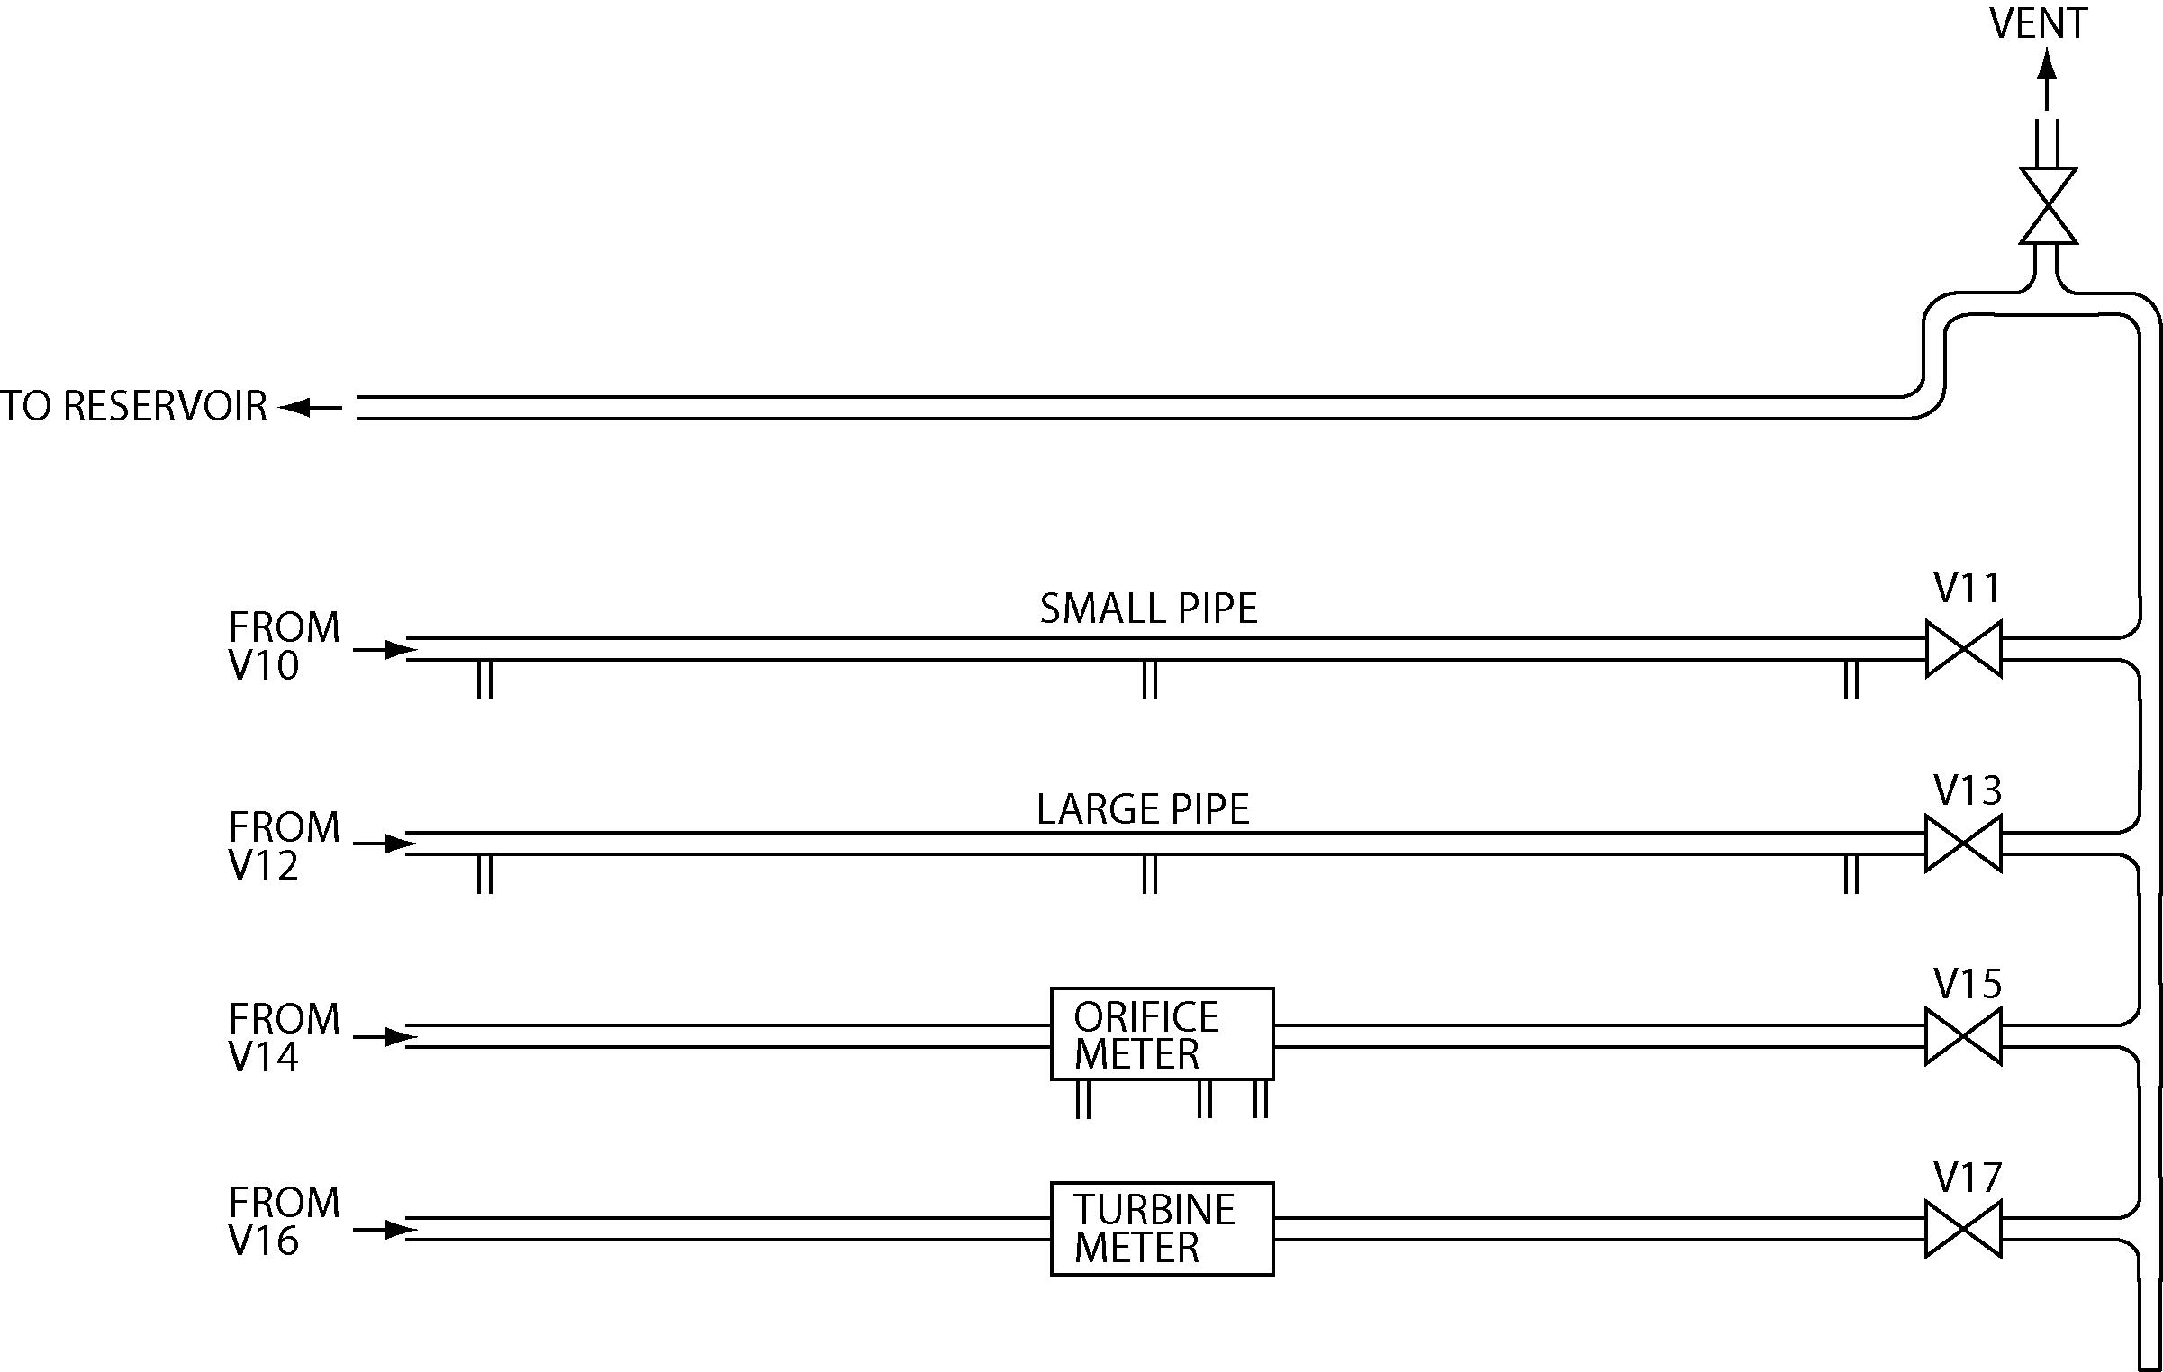
Figure 5: Pipe network. The double vertical lines below the small pipe, large pipe and orifice meter indicate the positions of pressure taps. In this lab, you will only use the bottom two pipes (recall that you used the top two for the EK 304 pipe friction lab).
Vertical Manometer
LPM
HPM
Inclined Manometer
Bleed
No Connection
LPM: Low Pressure Manifold
HPM: High Pressure Manifold
Orifice: Loss
Inclined Manometer
Vertical Manometer
Orifice: downstream from plate
Bleed
Large pipe: middle
Large pipe: end
Small pipe: middle
Small pipe: end
No Connection
No Connection
Small pipe: beginning
Small pipe: middle
Large pipe: beginning
No Connection
Orifice: upstream of plate
Vertical Manometer
Inclined Manometer
Figure 6: Diagram of manometers used in the lab with connections key for the pressure taps in the pipe network
- Detailed Procedures

  - Calibration of Rotameter (Bucket and Stopwatch Method)

The rotameters must be calibrated in order to establish their accuracy. They all have previously been calibrated, but as an exercise you will verify the calibration of the medium flowmeter. Data for the medium rotameter should be taken for at least five different flow rates throughout its range.

Place an empty bucket on the weighing scale and determine its weight. (It may be possible to use the “zero-adjust” on the weighing scale to make it read zero with the empty bucket on it.)

For calibration, close valves 10 through 17, open V9, and adjust V7, the valve at the bottom of the medium rotameter, so as to get a specific reading on the rotameter. Collect water in the bucket for a known period of time, e.g., 60 seconds. If the weight of the water collected exceeds the range of the scale, then repeat water collection for a smaller duration.

While collecting water, the open end of the flexible outlet tube must be maintained at a constant height and remain filled with water additionally, it must not be submerged in the water. Why? To keep it filled with water, turn up its open end. Also, the water level in the reservoir tank must not change during calibration. Be sure to fill it with tap water at a rate so it just overflows into the sink while you run your calibration.

Now weigh the bucket and water. The difference in readings before and after water collection should enable you to estimate the volume flow rate corresponding to the specific reading of the flowmeter.

SPOT CHECK: In your lab book, plot GPM (measured) vs GPM (indicated).

Record the temperature of the water in the reservoir at the beginning and at the end of the experiment. Why is it important to monitor the temperature? Check that the “vertical” manometer is truly vertical and that the inclined manometer is at 30 degrees up from the horizontal; Adjust as necessary.

  - Calibration of Turbine Flowmeter

The large and medium rotameters will be used to calibrate the turbine flow meter. To begin the calibration, direct all flow from the pump through the large rotameter and the turbine meter.

Set the flow through the large manometer to 9gpm. Set the counter/timer to pulse measurement (totalize). Press and release the RESET button to start the counter; press the hold button to freeze the display. Count pulses for at least 30 seconds or for 100 pulses, whichever is LONGER. (Be sure to record how long you count the pulses). Repeat for 9 gpm using the meter set on frequency (auto-ranging scale), also record the voltage and current output signals coming from the signal conditioner.

SPOT CHECK: (DONE FOR 9 GPM FLOWRATE ONLY): Compare frequency calculated from the oscilloscope (1/period) to the frequency reading from the counter/timer and to the frequency calculated from the number of pulses in a given time period. Knowing the flow rate to be 9 gpm, compute the number of pulses per gallon of flow produced by the turbine. Compare the current and voltage measurement from the signal conditioner to the expected values given in the calibration sheet (see Figure 8). Check both the “Frequency” calibration and the “Flow Rate” calibration and comment on how this is related to the error in the turbine meter response. Assume the signal conditioner has a linear response.

Repeat measurements of pulses, frequency, voltage, and current (but not spot check) for flow rates of 7, 5, 3, and 1 gpm through the large rotameter, and for flow rates of 100%, 80%, 60%, 40%, 20%, and 10% on the medium rotameter.

Keep an eye on the rotameter while you are performing this calibration and subsequent procedures, as the reading may drift by as much as 5%. If you catch it quickly and adjust the feed valve, it won’t have much effect on your reading.

  - Calibration of Orifice Meter

Set the large rotameter for maximum flow (9 gpm). Direct the flow from the rotameter through the orifice meter. Measure the pressure drop across the orifice meter using the manometers.

WARNING: Take care that the pressure drop across the flowmeter does not exceed the capacity of the manometers. Always close the manometer taps before increasing the flow or adjusting the manifold stopcocks.

Repeat for the same flow rates as for the turbine meter. For small Δp, use the inclined manometer. Be sure to check zero readings both before and after the run.

- Results

1. Plot the calibration curves for the rotameter, turbine flowmeter, and orifice meter. The rotameter calibration should be plotted as gpm (indicated) vs gpm (actual).

You should have three plots for the turbine flowmeter:
a. The number of pulses per minute vs. the indicated flowrate on the rotameter
b. The signal conditioner’s output current vs. the indicated flowrate on the rotameter
c. The voltage across the nominally 200 ohm resistor vs. the indicated flowrate on the rotameter.

The orifice meter calibration should be plotted with (Δp)^{1/2} (indicated) vs gpm.

3. Compute and plot (vs. flowrate) the value of K for each data point taken for the orifice meter.

4. Compute the theoretically expected calibration curve for the orifice meter [(Δp)^{1/2} vs Q] and plot that on the same sheet as the experimental calibration points obtained from this experiment. For the theoretical curve, use an average accepted value for K, not your experimental value. Comment on the effect of the change in K with flowrate.

5. Using the appropriate data, compute an average value of the number of pulses per gallon generated by the turbine meter. Compare your value with the one in the specification sheet for the turbine meter found in Figure 7.

6. Using the appropriate data, compute an average value for the number of milliamps (out of the pulse to DC converter) per gpm flowing through the turbine meter. Compare your value to the one in the specification sheet found in Figure 8.

7. Compare the voltage measured across the resistor and the current from the signal conditioner (Hint: you will have to use Ohm’s law)
- Data Appendix

Meters:
Orifice diameter 0.750 inches
Pipe diameter 1.000 inches

Rotameter Calibration:
Medium rotameter 2.53 gpm at full scale

- Additional Reading

Dally, James W., William F. Riley, and Kenneth G. McConnell. Instrumentation for Engineering Measurements. 2nd ed. John Wiley & Sons, 1992. Pgs. 481-486, 534- 537.
Beckwith, Thomas G., N. Lewis Buck, and Roy D. Marangoni. Mechanical
Measurements. Reading, Massachusetts: Addison-Wesley, 1982. Pgs: 449-454, 483-494.

Holman, Jack P. Experimental Methods for Engineers. New York: Wiley, 1995. Pgs. 216- 229.

Figliola, Richard S. and Donald E. Beasley. Theory and Design for Mechanical
Measurements. 2nd ed. New York: Wiley, 1995. Chapter 9.

- Authors

Written by Dr. Bala Bharadvaj (Aug. 1982)
Revised by Mr. Mike Ravicz and Dr. Mort Isaacson (Jan. 1988)
New apparatus built by Mr. Ron Garriques (Jun. 1986)
Apparatus revised by Mr. Mike Ravicz (Jan. 1988)
Revision G by J. O. Turner (Feb. 1988)
Revised by Dr. Mort Isaacson, Sam Bogan and Greg Richardson (Sept. 1991)
Revised by Dr. Mort Isaacson (Mar. and Dec. 1992)
Revised by Dr. Mort Isaacson and Dale Edwards (Aug. 1996)
Apparatus rebuilt by Joe Estano (Aug. 2000)
Revised by Alex Lehman and R. G. Holt (Aug. 2001)
Revised by C. Thomas and Dr. R.G. Holt(Aug, 2003)

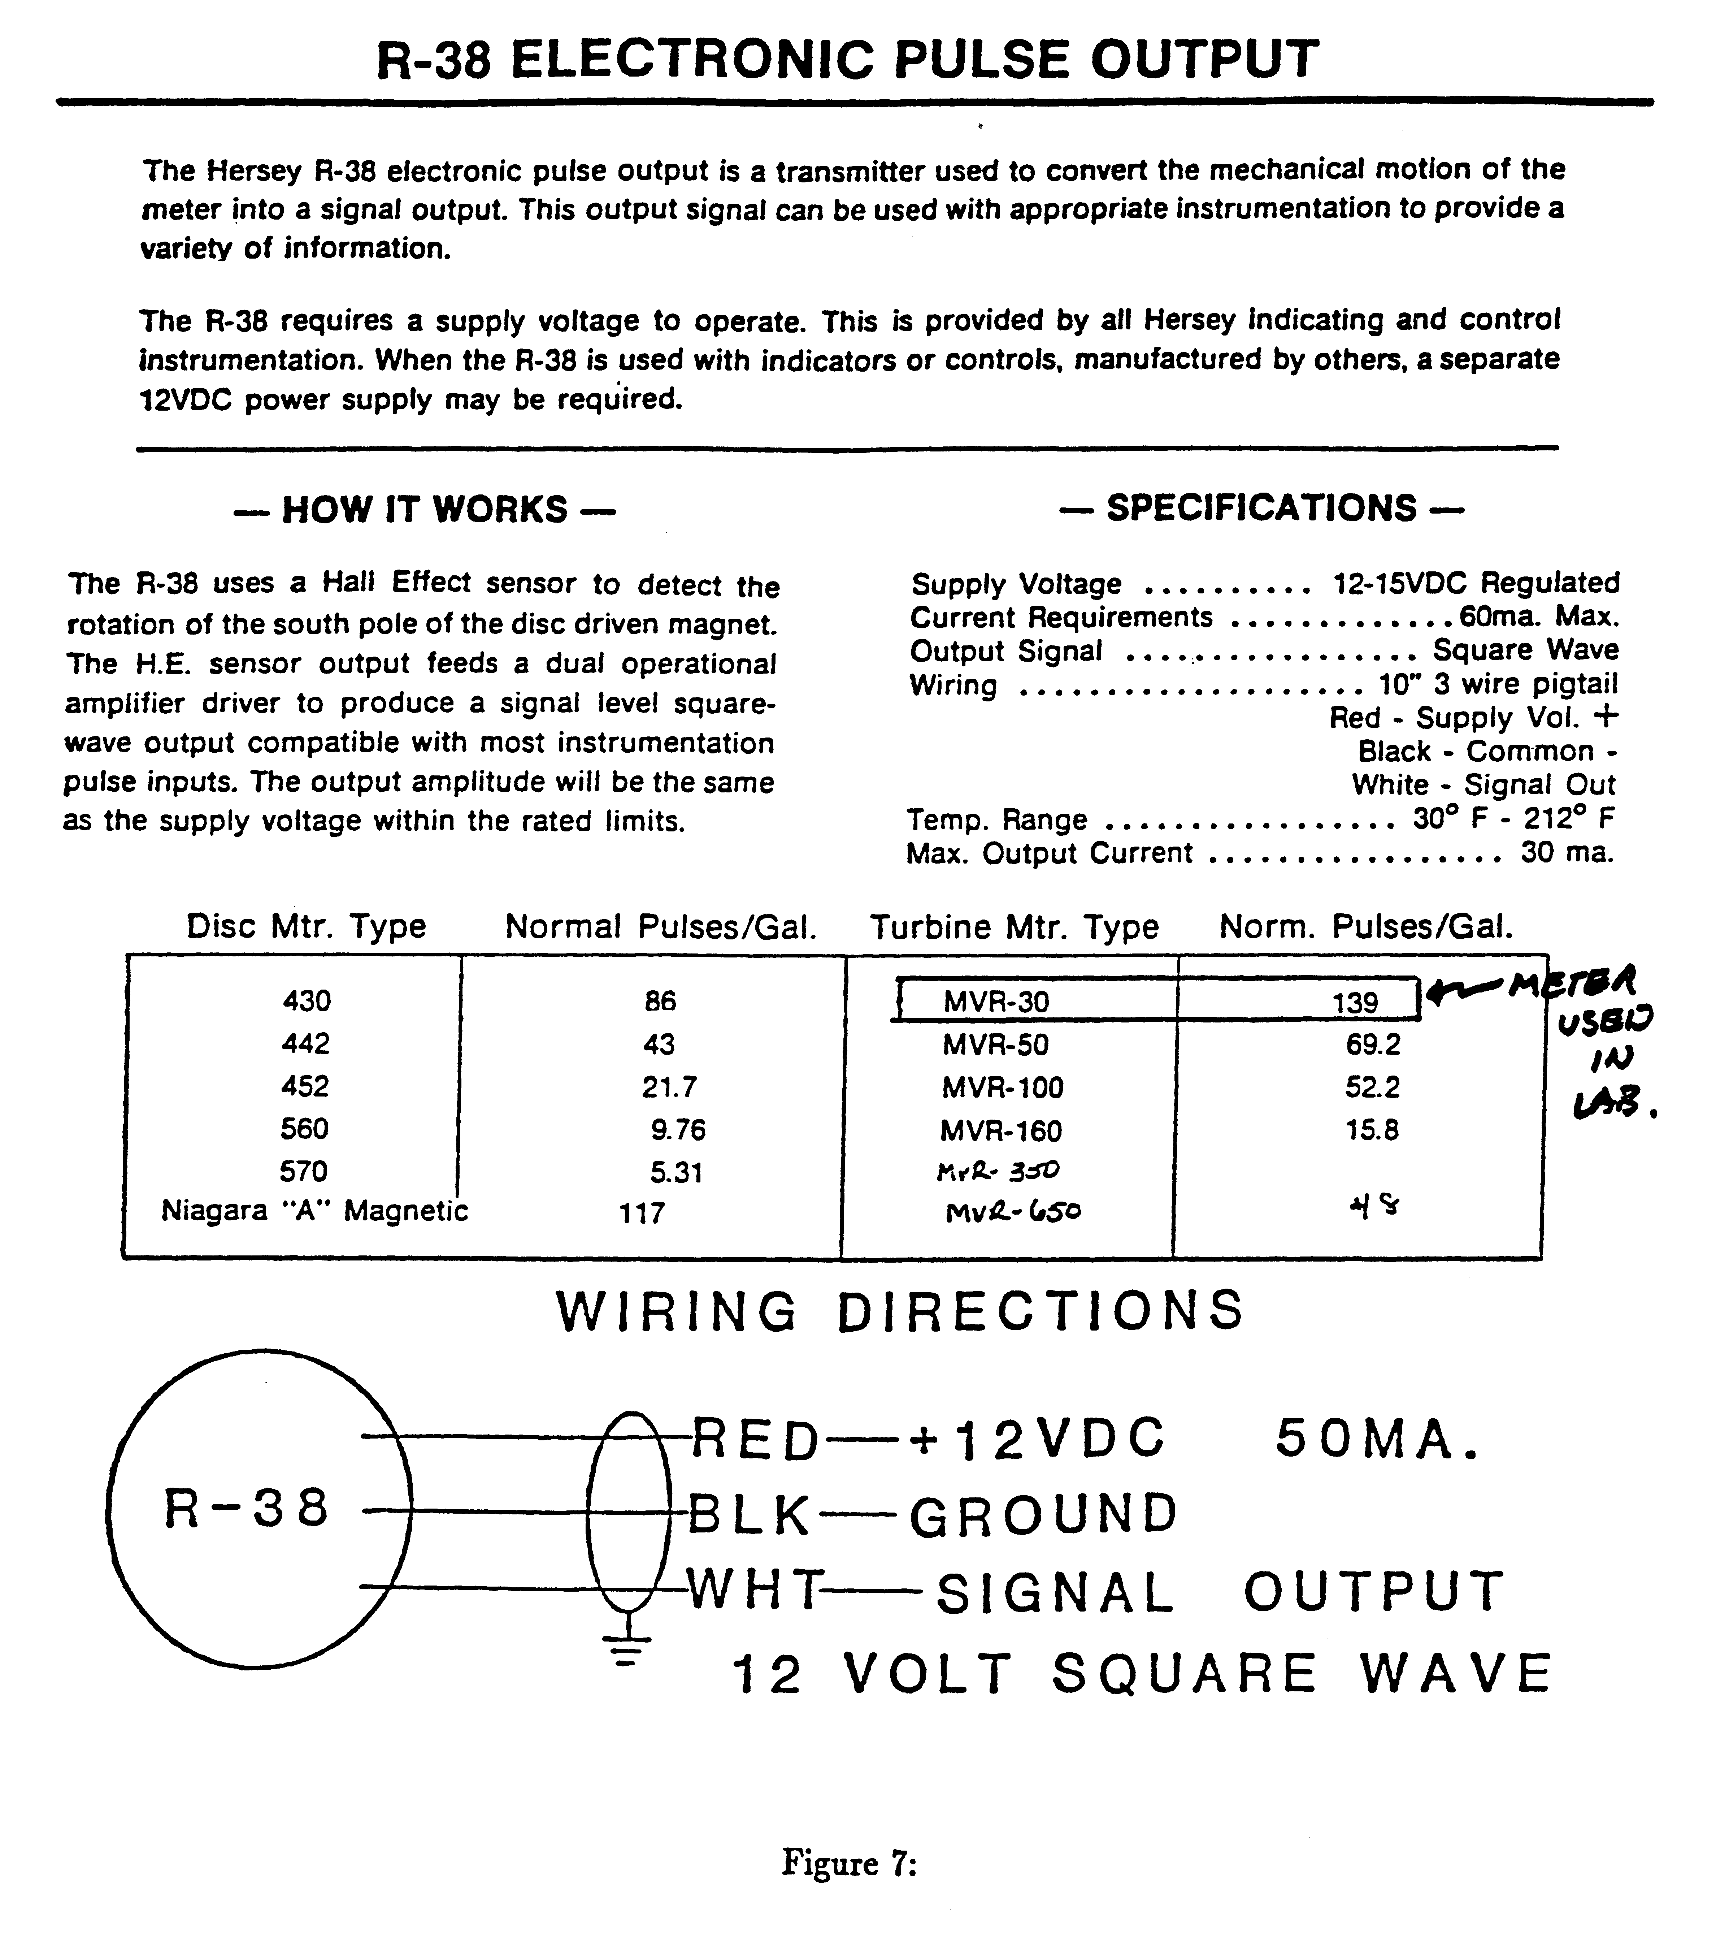
Figure 7: Specification sheet for turbine meter
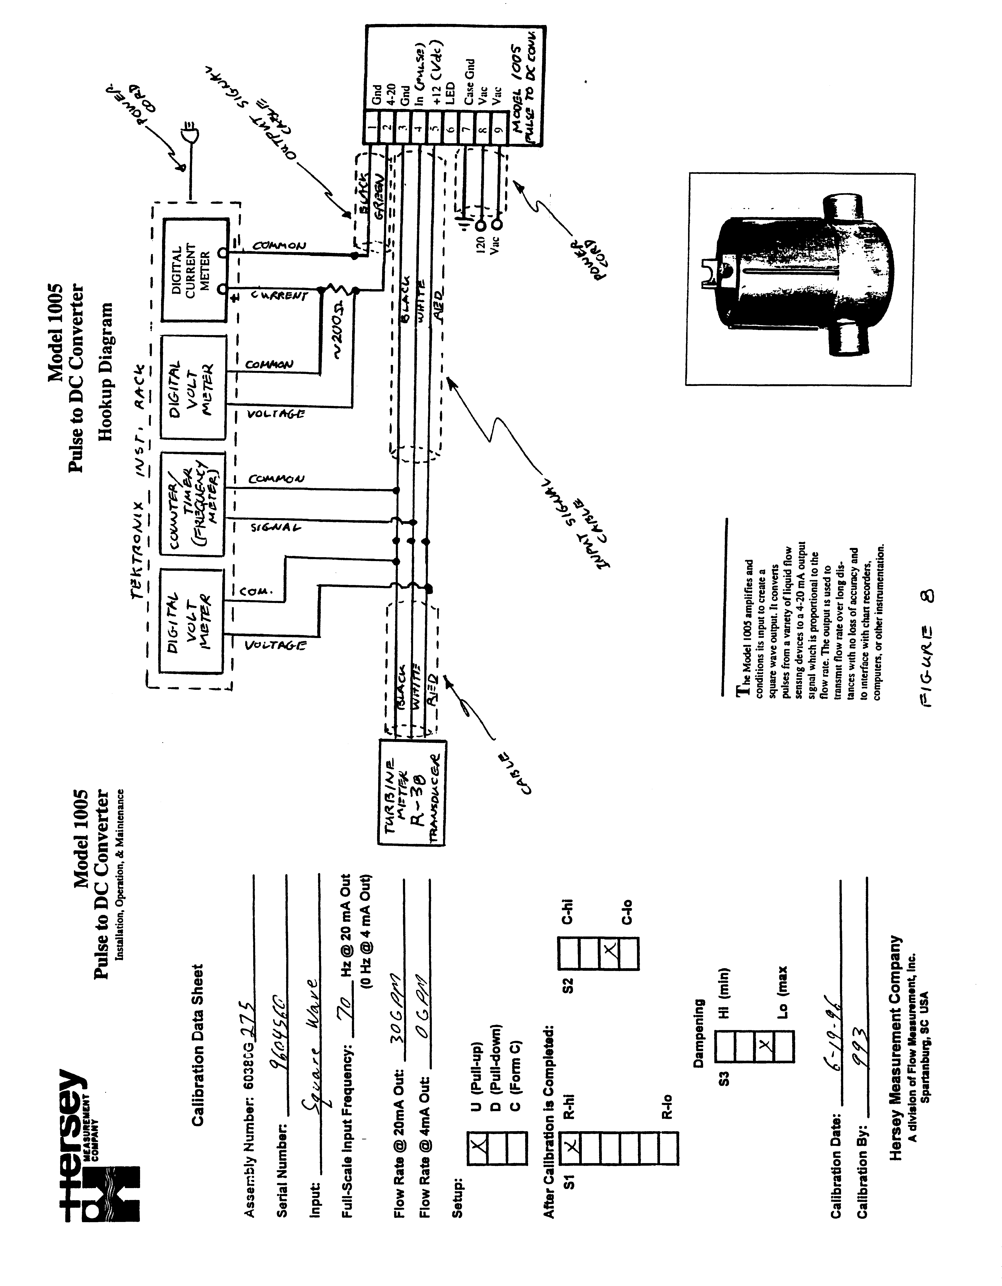
Figure 8: Specification Sheet for pulse to DC converter and wiring diagram

